CODE:
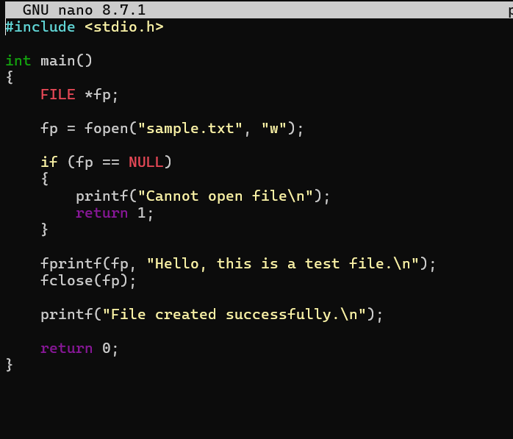

TASK OF THE DAY
1) Give Read and Write only to the owner
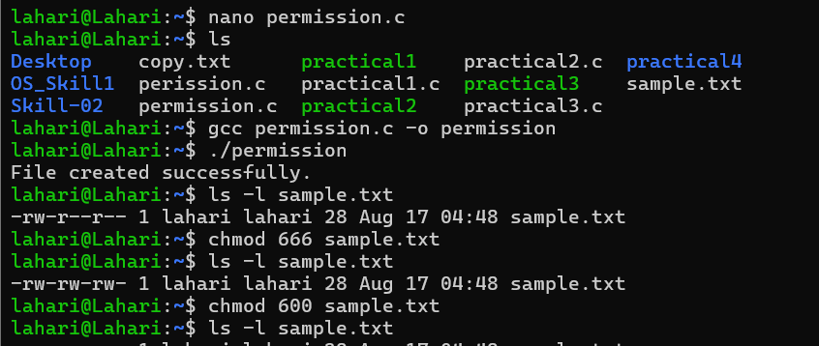
2) Give Read and Write to the owner and group

3) Only owner can read and write
4) Owner read/write, everyone else read-only
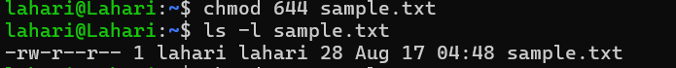
5) Owner can do everything, others can only read and execute
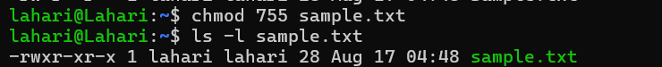

6) Owner and group can read/write
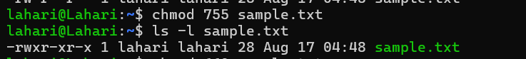
7) Only owner can execute
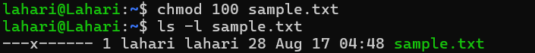

Fill in the permission numbers for the following:
8) Owner: read + write; Group: nothing; Others: nothing →___600_________
9) Owner: read + write; Group: read; Others: read → ___644______
10) Owner: read + write + execute; Group: read + execute; Others: read + execute → _755________
11) Owner: read + write; Group: read + write; Others: nothing → ____660________
12) Everyone: read only → ___444_________

WHOLE OUTPUT
